CONSULTING SERVICES DESIGNING REGIONAL PLATFORM

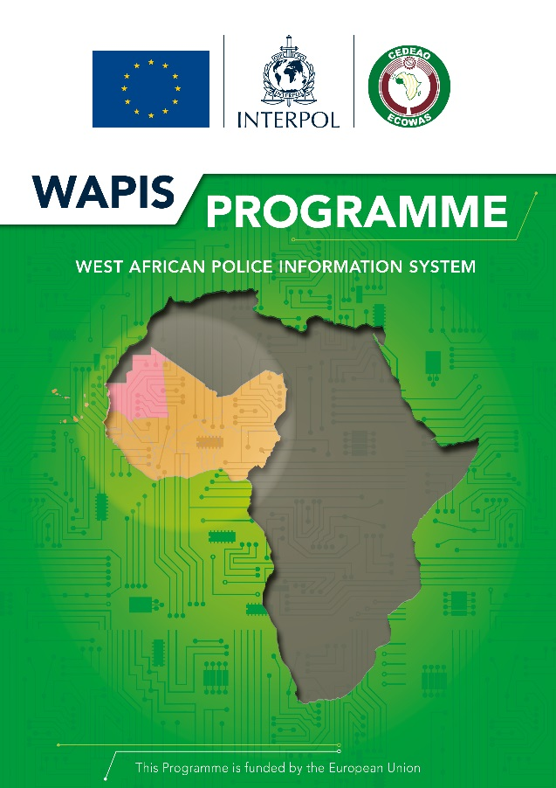

Contents
1 BACKGROUND OF THE WAPIS PROGRAMME 4
2 DESCRIPTION OF THE CONSULTING SERVICES 5
3 VENUES, TIMING AND DURATION OF ASSIGNMENT 7
4 OUTPUT/REPORTING REQUIREMENTS 7
5 PROFILE OF THE CONSULTANTS 9

List of Abbreviations

AIRCOP Airport Communication Project
CCSS Committee of Chiefs of Security Services
DACORE Data Collection and Registration (Centre)
DEVCO Development and Cooperation Aid
ECOWAS Economic Community Of West African States
EDF European Development Fund
EEAS European External Action Service
EU European Union
EUCAP European Union Capacity Building Mission
EULOs European Liaison Officers (platforms)
IfS Instrument for Stability
IT Information Technology
KPI Key Performance Indicators
LEA Law Enforcement Agency
MoU Memorandum of Understanding
NCB (INTERPOL) National Central Bureau
PAJED Programme d’Appui à la Justice et à l’Etat de Droit
PCMS Plateforme de Coopération en Matière de Sécurité
RIP Regional Indicative Programme
SEACOP Seaport Communication Project
SOP Standard Operating Procedure
SPOC Single Point Of Contact
SRIEU Special Representative of Interpol to the European Union
TOC Transnational Organised Crime
UNODC United Nations Office on Drugs and Crime
WANACO WAPIS National Committee
WAPCCO West African Police Chiefs Committee
WAPIS West African Police Information System

- BACKGROUND OF THE WAPIS PROGRAMME

The West African Police Information System (WAPIS) Programme aims at responding to some of the security challenges faced by the West African countries, by allowing an effective collection of police information thanks to a centralized national system and by offering the possibility of sharing the information collected at national, regional and international levels. The aim of WAPIS is for citizens of ECOWAS member states to benefit from the principle of free movement. Since organised crime and terrorism know no borders, especially in West Africa where borders are porous, it is essential for law enforcement authorities in the region to be able to know quickly if an individual is wanted by another country or if an ID document or a vehicle is reported as stolen.
The request to develop this system was put forward by the Economic Community of West African States (ECOWAS) in 2011. Since 2011, the WAPIS Programme has officially been endorsed both at ministerial level (Ministers in charge of security gathered in the framework of the Committee of Chief of Security Services - CCSS) and Heads of Police level (gathered in the framework of the West African Police Chiefs Committee – WAPCCO).
Implemented with the financial support of the European Union (EU) under the instrument contributing to stability and peace, two (2) phases of the WAPIS Programme have been successfully completed. The first phase (September 2012 – September 2013) was intended as a preparation and planning phase, conducted in cooperation with pilot countries (Benin, Ghana, Mali and Niger – Mauritania as an observer). The second phase (October 2013 - February 2016) launched the implementation of the Programme in the four (4) pilot countries.
The transition period to the third phase of the Programme (February 2016 – December 2020) supported the strengthening of police information systems in the broader West Africa region. Expected results of this phase were that the WAPIS System was to be fully operationalized in the four (4) original pilot countries and that favourable conditions would be created to enable collection, centralization, management and sharing of police data through the WAPIS System in the other four (4) countries: Burkina Faso, Chad, Côte d’Ivoire and Mauritania.
The third phase of the Programme, funded by the 11th European Development Fund started on 15 November 2017 for an implementation period of 55 months, with a budget of 28 million Euros and will end by June 2022. This phase is about implementing the WAPIS System at the national level in all ECOWAS Member States and possibly Mauritania, through providing operational and technical support as well as appropriate training on the system and to develop and install a regional platform for data exchange between ECOWAS Member States. Moreover this phase is intended to, at the global level, connect each national WAPIS System to the country’s INTERPOL National Central Bureau (NCB) in order to share authorized national data globally through INTERPOL’s I-24/7 system.

- DESCRIPTION OF THE CONSULTING SERVICES

The WAPIS Programme is seeking a consulting service that will assist in developing and implementing the WAPIS regional data sharing mechanism.
The specific objectives of the consulting service are to:
- Support the Programme to assist the participating countries and ECOWAS in defining operational processes for data processing and exchanging at the regional level
- Support the Programme in defining the functional and technical specifications of the regional data sharing mechanism in line with the defined operational processes for data processing and exchanging at the regional level
The expected results are:
- The operational processes for data processing and exchange at the regional level are defined and adopted during a dedicated ECOWAS expert’s committee workshop to be organized.
- The functional and technical specifications of the regional data sharing mechanism are drafted, to support a tender process to be launched by the Programme.

The scope of work
 | Activities | Deliverables | Deadline
01 | Collect all relevant information on WAPIS Programme and prepare an inception report providing a detailed action plan for the delivery of a regional data sharing mechanism | The inception report | T0+ 1 month
02 | Support the organization of an ECOWAS expert’s committee workshop related to the regional mechanism platform to define the operational processes for data processing and exchange at the regional level  - Preparation of the agenda  - Selection of the participants  - Preparation of the support material and contents for the meeting  - Facilitation of the meeting  - Report of the meeting | - Report of the Meeting  - Research Paper on the operational processes defined for data processing and exchange at the regional level | T0+ 3 months
03 | Develop the functional and technical specifications based on the operational processes for data processing and exchanging at the regional level defined during the ECOWAS Experts Committee. | - The Functional and technical specifications of the regional data sharing platform | T0+4 months

VENUES, TIMING AND DURATION OF ASSIGNMENT

The duration of the assignment will be until the end of the project (June 2022).
The consultant services will undertake the assignment from the Annex of the regional Bureau for West Africa in Abidjan, where the WAPIS Programme team is based.
In agreement with Programme Management, the consultant can undertake some assignments remote based and can be required to travel to the participant countries.

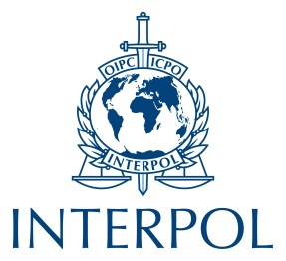
General Secretariat
200 quai Charles de Gaulle
69006 Lyon
France
Tel: +33 4 72 44 70 00
Fax: +33 4 72 44 71 63
Twitter: @INTERPOL_HQ
YouTube: INTERPOLHQ
www.interpol.int

PROFILE OF THE CONSULTANTS

- Excellent knowledge of Police data information management systems and methodologies
- Knowledge of existing regional data sharing mechanisms such as SIS, ECRIS
- Experience in managing IT projects as well as piloting and interacting with remote suppliers in the perimeter of a complex organizational framework
- Experience in handling sensitive data and managing security issues in a complex political and operational context
- Strong skills in IS Business architecture, IS system infrastructure
- Experience of working in west Africa region is desirable
- Proficiency in English and French is required
- Excellent facilitation and interpersonal skills.
- Excellent documentation and report skills

